**ABSTRUCT:** A low-cost, mobile-based system is proposed to monitor infants in the workplace. The system uses IoT devices and real-time video transfer to monitor infants and detect safety hazards. The system also includes a video calling feature. The system is powered by an ESP32 microcontroller and is designed to be low-cost and easy to use. The system has the potential to provide peace of mind, improve safety, and increase productivity for working mothers in the RMG sector. The system is still under development, but it has the potential to be a valuable tool for many families. Here are some of the key features of the system: IoT devices monitor the baby's movements, cries, and environment. Data from the IoT devices is sent to the mother's mobile phone. The mother's mobile phone analyzes the data and sends alerts if any anomalies are detected. The system also includes a video calling feature so that the mother can see the baby in real time. The system is a promising solution for the challenges faced by working mothers in the RMG sector. It has the potential to improve the safety and well-being of babies, and to help mothers to be more productive at work.

**Chapter One**

**INTRODUCTION**

**1.1 General Background**

The ready-made garment (RMG) sector is the largest export sector in Bangladesh, accounting for about 80% of total exports and 13% of GDP. The RMG sector employs about 4 million people, of which 80% are women. The RMG sector has played a significant role in the economic development of Bangladesh, helping to reduce poverty and improve the lives of women. Women working in the RMG sector have reported increased income, decision-making power, and social status [1]. However, the challenges are even more pronounced for women who are pregnant or who have recently given birth.

Some of the specific challenges that pregnant garment workers face include:

* **Physical demands of the work:** The work in the garment sector can be physically demanding, requiring workers to stand for long periods of time, lift heavy objects, and work in cramped spaces. This can be especially difficult for pregnant women, who may experience fatigue, nausea, and other pregnancy-related symptoms.
* **Exposure to hazardous chemicals:** Garment workers are often exposed to hazardous chemicals, such as those used in the dyeing and finishing processes. These chemicals can pose a health risk to pregnant women and their unborn babies.
* **Lack of access to health care:** Many garment workers do not have access to adequate health care, which can make it difficult for them to get the care they need during pregnancy and after childbirth.
* **Discrimination:** Pregnant garment workers may face discrimination from their employers, such as being denied leave or being fired.

Women who have recently given birth also face a number of challenges, including:

Need to breastfeed: Breastfeeding is important for the health of both the mother and the baby, but it can be difficult for garment workers to breastfeed due to long working hours and lack of access to clean water and a safe place to pump milk.

Difficulties in finding childcare: Many garment workers cannot afford childcare, which can make it difficult for them to return to work after childbirth.

Financial constraints: Many garment workers are unable to afford the costs of raising a child, such as food, clothing, and education.

The challenges faced by women working in the garment sector during pregnancy and after childbirth can have a negative impact on their health, their families, and their economic security. It is important to address these challenges in order to ensure that all women have the opportunity to work in a safe and healthy environment and to raise healthy families. A women is working in garments is shown in figure 1.

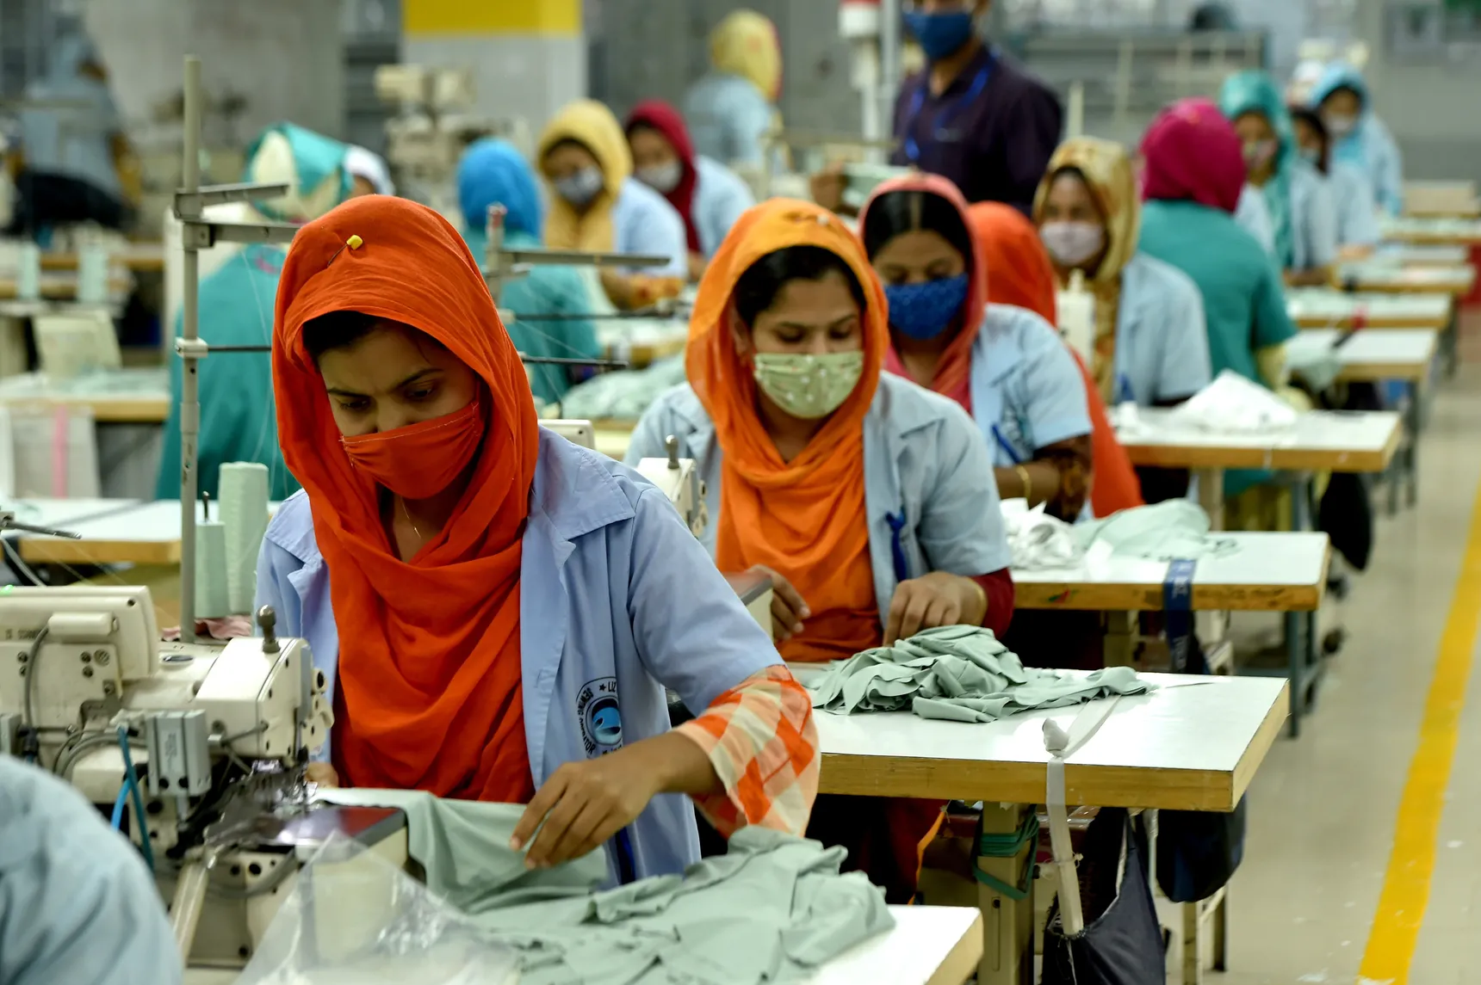

Figure 1: Working women in garments industry. [2]

**1.2 Motivation**

The garment industry is a major source of employment in Bangladesh, with millions of people, including many women, working in garment factories. However, the working conditions in garment factories can be harsh, and many garment workers cannot afford childcare. This can lead to working mothers having to bring their infants to work with them, which can be dangerous for both the infants and the mothers. A system for monitoring infants in the workplace could help to address this challenge. Such a system could provide peace of mind to mothers by allowing them to track their child's cry. In addition to providing peace of mind to mothers, a system for monitoring infants in the workplace could also have a number of other benefits. For example, it could help to monitor the baby in real time through video transmission, provides a suggestion based on it’s cry as well as a safe environment for the baby. It could also help to improve productivity by reducing the amount of time that mothers have to take off work to care for their children. The development of a system for monitoring infants in the workplace is a complex and challenging task. However, the potential benefits of such a system are significant. By providing peace of mind to mothers, and improving productivity, a system for monitoring infants in the workplace could make a real difference in the lives of working mothers and their babies.

**1.2.1 Problem Statement**

Working in a garments industry requires a high concentration for large and fast productivity. As most of the garment’s workers are woman and they need to pay attention to their child at the same time of working. Babies in the industry daycare provides a good solution for those babies whose age are more than 2 to 4+ years but babies having ae lower than that age need high and immediate attention. In this case, we need a technological solution which can link between work and take care. The major problems are to take care of a baby at the time of need for hungry, discomfort, burping, as well as urination. The presence of mother at the same time with the baby and in the work is a very time crucial matter to consider. As a frontier technology IoT(Internet of Things) and ML(Machine Learning) can be considered to solve this problem.

**1.2.2 Objectives of the Research Report**

* **To develop a system that can safely and securely monitor infants in the workplace:** This would involve using sensors and Mobile application technologies to track the infant's vital signs. The system would also need to be able to alert mother if there is a problem.
* **To make the system affordable and accessible to businesses of all sizes:** This would involve using cost-effective components and developing a user-friendly interface.
* **To ensure that the system is compliant with all applicable regulations:** This would involve working with regulatory bodies to ensure that the system meets all safety and security requirements.
* **To evaluate the effectiveness of the system in a real-world setting:** This would involve conducting trials with businesses and families to assess the system's performance.

**1.3 Literature Review**

The garment industry plays a significant role in Bangladesh's economy, employing a substantial female workforce. However, the lack of affordable and accessible childcare options compels many female garment workers to bring their babies to the workplace. This practice poses various challenges that affect both the mothers and their infants [3]. The economic vulnerability of these workers and their limited access to quality childcare services are driving factors behind the decision to bring infants to the workplace. This phenomenon underscores the need for a comprehensive understanding of the issue and the development of sustainable solutions [4]. Bringing babies to work presents emotional, physical, and psychological challenges for the mothers, who must balance their job responsibilities with childcare. Infants, in turn, are exposed to suboptimal environments, lack of proper care, and the risk of accidents [5]. Garment authorities have made efforts to address this issue by providing designated areas for babies within factories and hiring caregivers. However, these measures are not fully effective in ensuring the well-being of both mothers and infants [6]. To solve this problem authors in [7] presented an IoT-based baby monitoring system utilizing wireless sensor networks for comprehensive monitoring of infants' movements and well-being. Similarly, authors in [8] proposed a real-time monitoring system for infant sleep apnea, incorporating IoT technology to detect potential health issues and provide timely alerts. These studies emphasize the potential of IoT in ensuring infants' safety and health. Researchers have explored the integration of IoT in smart cradles and cribs for continuous monitoring. The development of an IoT-based smart cradle that monitors infant movements and conditions, enhancing caregivers' ability to ensure infants' comfort and safety was presented in [9]. Additionally, a system of an IoT-based baby monitoring system using Raspberry Pi, allowing caregivers to remotely monitor infants' activities and well-being is proposed in [10]. The ability to remotely monitor infants and receive alerts has been a focal point of several studies. Authors in [11] presented a real-time baby monitoring and healthcare system using IoT, enabling remote monitoring and timely interventions in case of emergencies. Another researcher proposed an IoT-based smart baby monitoring system that provides caregivers with real-time alerts and remote monitoring capabilities [12]. In addition to the proposed technologies infant’s health care and safety measures was studied. Authors introduced an IoT-based baby health monitoring system that tracks vital signs and provides real-time alerts to caregivers in case of any anomalies [13]. Similarly, authors have developed an IoT-enabled system for monitoring and controlling the crib environment, enhancing infants' safety and caregivers' peace of mind [14]. The integration of machine learning (ML) techniques into baby monitoring systems has opened new avenues for enhancing infant care and safety. Machine learning algorithms have been utilized to monitor the health and well-being of infants. Authors proposed an ML-based method to detect infant respiratory distress syndrome using physiological signals, offering accurate and early detection of potential health issues [15]. Machine learning algorithms have shown promising results in recognizing infant activities and sleep patterns. Authors developed an ML-based algorithm for automatic detection of infant movements and sleep postures using accelerometer data, contributing to comprehensive sleep analysis [16]. Such systems offer insights into infant behavior and sleep quality, aiding caregivers in understanding infants' needs. ML algorithms have been integrated into smart cribs to monitor infants' environment and safety. Authors developed an ML-based system for real-time crib monitoring, detecting risky situations such as infants rolling over and unsafe sleep postures [17]. This approach contributes to reducing the risk of sudden infant death syndrome (SIDS) and enhancing infant safety. From the literature review none of work has been developed considering, low cost and optimum solution for the worker mother. In this research, to address the challenges faced by garment workers and their babies, we propose a low-cost solution utilizing technology. This solution involves the development of a mobile application that enables remote monitoring of babies through IoT devices and real-time video transfer. This application also includes features such as identification of baby cries, notification of baby movements, and safety measures like temperature and gas detection.

Top of Form

**1.4 Outline of the Research Report**

This research project describes the ways of development of a monitoring system of aged 3 month 1 years in the baby crib for garments working mothers in the workplace. The research cover data collection, data analysis and informative message collection, baby need analysis and system model generation. At first the necessity forms the garments worker are taken then after analyzing all the need and considering a lost cost solution for this large group of workers we proposed the entitled project for the garments industry. It includes existing problem statement, motivation, literature review, design methodology and Integration of the system as organized in the following manner.

Chapter 1 deals with the existing problem of baby monitoring for the working mothers in garments and a numerous technologies proposed by worldwide researchers to solve the problem.

Chapter 2 focuses on the proposed system and design architecture of the baby monitoring system. This section explains the hardware and software architecture in the system as well as their integration of functioning.

Chapter 3 focuses on the results and discusses on the performance, available data classification, considerations in baby safety issues.

Chapter 4 concludes with the summary of the work, the possible impacts of the system on our garments sector as well as future scope of baby monitoring in the associated sector.

**Chapter Two**

**PROPOSED SYSTEM AND METHODOLOGY**

## **2.1 System Architecture Overview**

To illustrate the system architecture, we have presented the system architecture through process a diagram shown in figure-2.

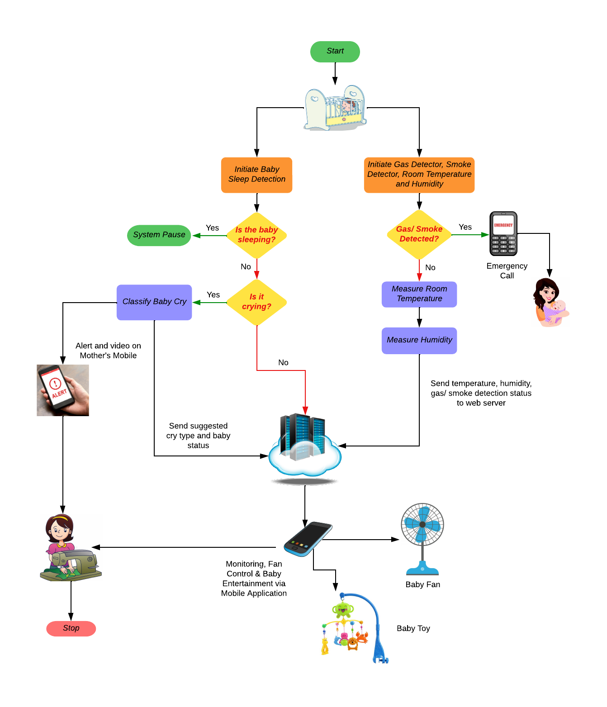

Figure 2 Block diagram of overall Architecture of the System.

The baby will be considered in the baby crib resides in a remote place at walking distance in the factory. The entire system is a combination of hardware system and a mobile application. After initializing the system baby sleep detection will be performed through a motion sensor as well as the initiation of LPG gas, Smoke detection, temperature and humidity measurement will be considered sequentially. These parameters are considered as safety issues. If any anomalies are detected an emergency mobile call will be generated immediately for mother’s help. The safety parameter will also be sent to the web server for monitoring baby from mother’s mobile application. In case of baby’s sleep detection baby motion will be accounted. The motion will be captured through motion sensor. If it detects no motion in the baby crib the system will pause its activity and enter into sleep mode. If a motion is detected, then sound detection module will work. In case of no sound from the sensor module only the baby status will be passed to the web server. But in case of baby cry, it will analyze the baby cry and generate a suggestion or action to be used by mother through her mobile application via web server.

## **2.2 Baby Sleep Detection**

When a human being or baby sleeps, it does not create any motion. So, we can sense a motion sensor to tract baby sleeping condition. The motion sensor is activated and measured for a particular time. For this project we have used the sensor for 30 seconds. If a motion within this time duration is detected then the activity of the baby is updated. The used Passive Infrared (PIR) motion sensor is a remarkable technological device widely used in various applications for detecting motion and human presence. This sensor functions by detecting changes in the infrared radiation emitted by objects in its field of view. When an object, such as a person, moves within the sensor's range, it emits a heat signature that triggers the sensor to generate an electrical signal. This signal is then processed to our ESP-32 Microcontroller unit to further action triggering. PIR motion sensors are known for their reliability and ability to active load immediately only when motion is detected. Figure-3 shows a PIR motion sensor.

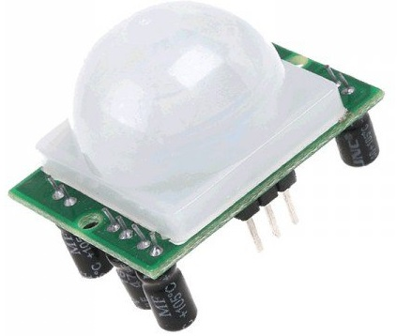

Figure-3 PIR Motion Sensor

## **2.3 Cry Detection and Classification Module**

The one and only way to express the need for a baby is the cry sound. It is the primary means of communication for newborns and infants upto one year old, and their cries can convey various needs and emotions. Understanding the different types of baby cries can help caregivers respond more effectively. Here are some common types of baby cry sounds in this age group:

1. **Hunger Cry:** This cry is often characterized by short, rhythmic bursts of crying. It's the most common type and indicates that the baby is hungry and needs to be fed.
2. **Tired Cry/ Discomfort:** Babies cry when they are tired or overstimulated or it may feel uncomforted due to wet diaper, tight clothing or an uncomforted position. This cry may be fussier and accompanied by rubbing their eyes or pulling at their ears. It signals the need for rest.
3. **Belly Pain/ Burping Cry:** Babies with gas or digestive issues may cry with a high-pitched or painful-sounding cry. Gentle massage and burping can help alleviate this cry. A cry of pain is usually sharp and sudden. It may indicate an injury, illness, or discomfort, such as colic or gas. Parents should seek medical attention if the cause is not obvious.
4. **Attention Seeker Cry:** Babies may cry simply because they want attention, interaction, or to be held. This cry is often less intense and more like whimpering.
5. **Overstimulated Cry:** When babies are overwhelmed by too much noise, activity, or stimuli, they may cry to express their discomfort. Calming the environment can help ease this cry.
6. **Sleepy Cry:** Similar to a tired cry, a sleepy cry occurs when a baby is ready for a nap or bedtime. It's often accompanied by yawning and rubbing their eyes.
7. **Frustration Cry:** As babies grow, they may cry out of frustration when they can't communicate their needs or desires. This cry can be accompanied by gestures or attempts to reach for objects.
8. **Teething Cry:** When teething, babies may experience discomfort and pain in their gums. This cry may be accompanied by chewing on objects or fingers.

We have collected a dataset from online [21] and for the convenience of the development of our system we have simplified the cry into three major different groups. These are:

1. Hungry cry.
2. Belly Pain or Burping cry.
3. Discomfort or Tired cry.

This classification is done based on the available dataset. After classification, the cry types with baby status are sent to the web server and an alert is sent to the mother’s mobile phone with video call. The classification is done based on the amplitudes achieved from the microphone/ transducer. The sound from the microphone are analog by nature and need to convert into digital one. After converting the sound into digital one we get some values in the range of 0 to 1023. At first, tested cry sound from the dataset was taken for training or realizing the system. After completing this phase some decisions are achieved which will predict the types of cry for further use by the system in the algorithm [18].

1. For belly pain/ burping the cry starts from 700 and minimum analog value starts from 100 on average.
2. For hungry cry the minimum ADC value starts from 130 and reaches to 180 while maximum ADC value starts from 500.
3. For Discomfort/ Tired cry the cry amplitude resides in the range of 80 to 500.

The logic is programmed through ESP-32 microcontroller and then transmitted to the server. Which is the main controller of the system. The ESP32 is a versatile and powerful microcontroller that has gained widespread popularity in the world of electronics and IoT (Internet of Things) development. Developed by Espressif Systems, the ESP32 is known for its dual-core processor, robust Wi-Fi and Bluetooth connectivity, and a rich set of peripherals and interfaces. This microcontroller is a favorite among developers for its ability to handle a wide range of applications, from simple sensor data acquisition to complex IoT projects. Its low power consumption and support for deep sleep modes make it ideal for battery-powered devices. Additionally, the ESP32 is well-supported by an active and vibrant open-source community, making it easier for developers to access a wealth of libraries, tutorials, and resources. Whether you're creating a smart home device, a wearable gadget, or a remote monitoring system, the ESP32 is a versatile and reliable choice that empowers innovation in the world of embedded electronics. The following figure shows a Esp-32 Microcontroller [19].

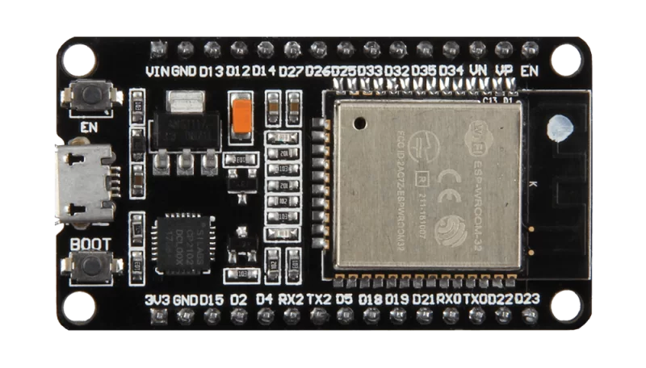

Figure-4: ESP-32 Microcontroller

## **2.4 LPG, Smoke, Room Temperature and Humidity Detection Module:**

The integration of an MQ2 sensor for LPG and smoke detection along with a DHT11 Temperature and Humidity sensor creates a robust monitoring system that offers enhanced safety and environmental control. The MQ2 sensor is adept at identifying potential gas leaks, especially LPG, and can promptly trigger alarms to avert dangerous situations, whether in homes or industrial settings. Simultaneously, the sensor's smoke detection capabilities provide crucial early warnings in the event of fire outbreaks, contributing to fire safety measures. The DHT11 sensor adds an extra layer of monitoring, enabling precise tracking of room temperature and humidity levels. This comprehensive system ensures not only the safety of the environment but also the comfort and well-being of occupants for the baby. At first LPG and Smoke are detected. If any undesired values are detected, then the system generates emergency mobile call to mother’s mobile phone. So, that the mother can understand that the emergency need of the baby. If such a situation is not considering or detected by the baby, then the system will measure the current temperature and humidity conditions and it will send these values to the web server. The following figure-5 shows a typical MQ2 and DHT-11 sensor:

|  |  |
| --- | --- |
|  |  |
| Figure-5: (a) MQ2 LPG, smoke and CO detector | Figure-5: (b) DHT-11 Temperature and Humidity Sensor |

### ***Mobile call generation circuitry***

The Mobile call generation circuitry, utilizing the A6 Mini GSM module in conjunction with an Esp-32 module, represents an intelligent and versatile solution for data acquisition and remote alerting. This innovative system amalgamates inputs from two essential sensors: the MQ2 gas sensor and the DHT-11 sensor. The A6 Mini GSM module shown in figure-6, equipped with its own SIM card, is capable of establishing mobile communication which is connected to the Esp-32 Module. It has the capability to initiate a mobile call to a predefined number, alerting relevant personnel or authorities about the observed anomaly. This direct and instantaneous communication enables prompt response to critical situations, ensuring the safety of individuals and the integrity of assets.

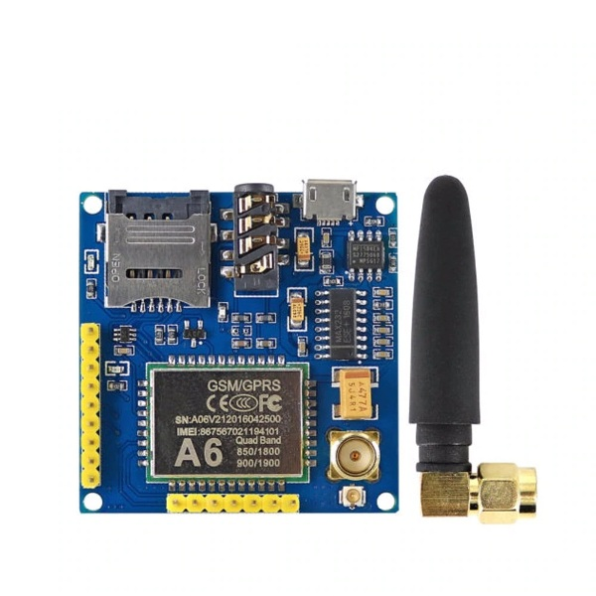

Figure-6: A6 Mini GSM/ GPRS Module.

## **Video Calling Methodology:**

The ESP32-CAM shown in figure [9] is a small, low-cost, and powerful camera module that is based on the ESP32 microcontroller. It has a built-in OV2640 camera sensor that can take 2MP images and 16fps videos. The module also has a microSD card slot for storing images and videos. The features of the ESP32-CAM those are the main reasons for choosing the device for this project are:

* ***WiFi and Bluetooth connectivity:*** The module can connect to WiFi and Bluetooth networks, allowing you to remotely control it or access the images and videos it takes.
* ***Built-in LED flash:*** The module has a built-in LED flash that can be used to illuminate the subject of a photo or video.
* ***Low power consumption:*** The module consumes very little power, making it ideal for battery-powered applications.

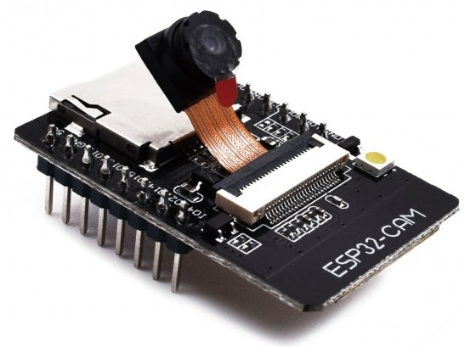

Figure-7: ESP-32 Cam Module

**Chapter Three**

**SOFTWARE ARCHITECTURE**

## **System Development Language:**

### ***HTML***

HTML stands for HyperText Markup Language. It is the standard markup language for creating web pages. HTML defines the structure of a web page by using tags. Tags are instructions that tell the browser how to display the content of the web page.

HTML is a text-based language, which means that it is made up of text and tags. The tags are enclosed in angle brackets (<>). The most common tags are the <html> tag, which defines the start of an HTML document, and the </html> tag, which defines the end of an HTML document. HTML is a powerful language that can be used to create a variety of web pages. It is relatively easy to learn, and there are many resources available to help you learn HTML.

In our project we use HTML for

* The `header` element, which contains the title of the web page
* The `main` element, which contains the main content of the web page
* The `table` element, which is used to display the sensor data
* The `button` elements, which the user can click to get the current value of the sensors

### ***CSS***

CSS stands for Cascading Style Sheets. It is a style sheet language used to describe the presentation of a document written in a markup language. CSS is used to control the appearance of web pages, such as the font, color, and size of the text, and the layout of the page. CSS is a separate language from HTML, but the two languages work together to create web pages. HTML is used to define the structure of the web page, and CSS is used to style the elements of the web page.

CSS is a powerful language that can be used to create a variety of effects. It is relatively easy to learn, and there are many resources available to help you learn CSS

In our project we use CSS for

* The background color of the web page
* The font size and color of the text
* The position of the buttons and the table

### ***JavaScript***

JavaScript is a lightweight, interpreted programming language. It is one of the three core technologies of the World Wide Web (WWW), along with HTML and CSS. JavaScript is used to make web pages interactive and to add dynamic content to web pages.

JavaScript is a client-side scripting language, which means that it is executed by the web browser. This makes it a powerful tool for creating interactive web pages that can respond to user input. JavaScript is a versatile language that can be used to do a variety of things, such as: Create animations and games, forms, Make AJAX requests, Create web services etc.

In our project we use JavaScript for,

* Get the current date and time from the browser
* Parse the XML data from the ESP
* Update the HTML page with the current value of the sensors

### ***XML***

XML stands for Extensible Markup Language. It is a markup language that is used to store and transport data. XML data is stored in a hierarchical format, which makes it easy to parse and process. XML is a text-based language, which means that it is made up of text and tags. The tags are enclosed in angle brackets (<>). The most common tags are the <xml> tag, which defines the start of an XML document, and the </xml> tag, which defines the end of an XML document.

In our project XML is used to store the current value of the sensors. The ESP-32 sends the data in XML format, and JavaScript is used to parse the XML data and update the HTML page accordingly.

### ***PHP***

PHP is a server-side scripting language that is used to create dynamic and interactive web pages. It is a general-purpose language that can be used for a variety of tasks, including Processing form data, generating dynamic content, Retrieving and storing data in databases, sending and receiving emails, Creating and managing sessions, Creating web services.

Some of the key features of PHP language are given here:

* It is a server-side scripting language, which means that it is executed on the server before the web page is sent to the client. This makes it a powerful tool for creating dynamic and interactive web pages.
* It is a general-purpose language, which means that it can be used for a variety of tasks. This makes it a versatile language that can be used to create a wide variety of web applications.
* It is open-source, which means that it is free to use and distribute. This makes it a cost-effective option for web development.
* It is well-supported, with a large community of developers and resources available. This makes it easy to learn and use.

In our project PHP is used to make web pages dynamic and attractive as well as, using PHP we handle the sensor database.

### ***MYSQL***

MySQL is a server-based database, which means that it runs on a computer called a server. The server stores the data in tables, which are made up of rows and columns. Each row represents a record, and each column represents a piece of data about that record.

MySQL uses a Structured Query Language (SQL) to interact with the data. SQL is a standard language for querying databases, and it is used to create, update, and delete data. MySQL is a powerful and versatile database that can be used for a variety of tasks. It is a good choice for web applications, as it is fast, reliable, and scalable.

Here are some of the key features of MySQL:

* Open-source: MySQL is free to use and distribute.
* Relational: MySQL stores data in tables, which are related to each other.
* SQL: MySQL uses SQL to interact with the data.
* Fast: MySQL is a fast database that can handle a lot of traffic.
* Reliable: MySQL is a reliable database that is used by many large websites.
* Scalable: MySQL can be scaled to handle a lot of data.

Using MySQL we are storing sensor readings in a database for analyzing these for further use

## **User Interface Source Code:**

1. <!DOCTYPE html>
2. <html lang="en" class="js-focus-visible">
3. <title>Infant Monitoring System</title>
4. <style>
5. #myFrame, #websiteUrl, #closeButton {display: none;}
6. .containerPro{
7. margin: 0 auto;
8. width:100%;
9. background-color:rgb(123, 199, 212);
10. text-align: center;
11. padding: 10px;
12. }
13. table {
14. position: relative;
15. width:100%;
16. border-spacing: 0px;
17. margin:0 auto;
18. }
19. tr {
20. border: 1px solid white;
21. font-family: "Times New Roman", "Arial", sans-serif;
22. font-size: 20px;
23. }
24. th {
25. height: 20px;
26. padding: 3px 15px;
27. font-size: 35px;
28. background-color: #343a40;
29. color: #FFFFFF !important;
30. }
31. .tabledata {
32. font-size: 40px;
33. padding-left: 5px;
34. padding-right: 5px;
35. padding-bottom: 5px;
36. border-radius: 5px;
37. width: 350px;
38. background-color: #00AA00;
39. }
40. .tabletext {
41. font-size: 40px;
42. position: relative;
43. padding-left: 5px;
44. padding-right: 5px;
45. padding-bottom: 5px;
46. width: 340px;
47. border-radius: 5px;
48. background-color: #00AA00;
49. }
50. .bodytext {
51. font-family: "Times New Roman", "Arial", sans-serif;
52. font-size: 50px;
53. text-align: left;
54. font-weight: light;
55. border-radius: 5px;
56. display:inline;
57. }
58. .heading{
59. font-family: "Times New Roman", "Arial", sans-serif;
60. font-size: 50px;
61. }
62. .navbar {
63. width: 100%;
64. height: 50px;
65. margin: 0;
66. padding: 10px 0px;
67. background-color: #FFF;
68. color: #000000;
69. border-bottom: 5px solid #293578;
70. }
71. .fixed-top {
72. position: fixed;
73. top: 0;
74. right: 0;
75. left: 0;
76. z-index: 1030;
77. }
78. .navtitle {
79. float: center;
80. height: 50px;
81. font-family: "Times New Roman", "Arial", sans-serif;
82. font-size: 60px;
83. font-weight: bold;
84. line-height: 50px;
85. padding-left: 20px;
86. }
87. .heading {
88. font-family: "Times New Roman", "Arial", sans-serif;
89. font-weight: normal;
90. font-size: 28px;
91. text-align: left;
92. }
94. .btn {
95. background-color: #444444;
96. border: none;
97. color: white;
98. padding: 10px 20px;
99. text-align: center;
100. text-decoration: none;
101. display: inline-block;
102. font-size: 16px;
103. font-family: "Times New Roman", "sans-serif";
104. margin: 4px 2px;
105. border-radius: 10px;
106. cursor: pointer;
107. }
108. .container {
109. max-width: 1800px;
110. margin: 0 auto;
111. }
112. table tr:first-child th:first-child {
113. border-top-left-radius: 5px;
114. }
115. table tr:first-child th:last-child {
116. border-top-right-radius: 5px;
117. }
118. table tr:last-child td:first-child {
119. border-bottom-left-radius: 5px;
120. }
121. table tr:last-child td:last-child {
122. border-bottom-right-radius: 5px;
123. }
124. </style>
125. <body style="background-color: #efefef" onload="process()">
126. <div class="containerPro">
127. <header>
128. <div class="navbar fixed-top">
129. <div class="container"><div>
130. <div style = float:none class="navtitle">Infant Monitoring System</div>
131. </div>
132. </div>
133. </header>
134. <main class="container" style="margin-top:70px">
135. <div style="display:inline-block;">
136. <span style="float:left"><button style="font-size: 35px;" class="btn" id ="textButton" onclick="showlinkFrame()">Link</button></span>
137. <span style="float:left"><button style="font-size: 35px; width: 200px;" class="btn" id="viewButton" onclick="showFrame()">View</button></span>
139. <span style="float:left"><button style="font-size: 35px;" class="btn" id="closeButton" onclick="hideFrame()">Close</button></span>
140. <span><textarea style="margin:8px" id="websiteUrl" rows="1" cols="50"></textarea></span>
141. </div>
142. <div>
144. <iframe src="" id="myFrame" style="height: 480px; margin:0 auto; width: 640px;"></iframe>
145. </div> <br>
146. <div style="border-radius: 10px !important;">
147. <table style="width:50%">
148. <colgroup>
149. <col span="1" style="background-color:rgb(230,230,230); width: 20%; color:#000000 ;">
150. <col span="1" style="background-color:rgb(200,200,200); width: 15%; color:#000000 ;">
151. <col span="1" style="background-color:rgb(180,180,180); width: 15%; color:#000000 ;">
152. </colgroup>
153. <col span="2"style="background-color:rgb(0,0,0); color:#FFFFFF">
154. <col span="2"style="background-color:rgb(0,0,0); color:#FFFFFF">
155. <col span="2"style="background-color:rgb(0,0,0); color:#FFFFFF">
156. <tr>
157. <th colspan="1"><div style="font-size: 45px; text-align: center;" class="heading">Activity</div></th>
158. <th colspan="1"><div style="font-size: 45px; text-align: center;" class="heading">Condition</div></th>
159. </tr>
160. <tr>
161. <td><div class="tabletext">Baby Stutus</div></td>
162. <td><div class="tabledata" id = "switch_activity">Awake</div></td>
163. </tr>
164. <tr>
165. <td><div class="tabletext">Suggested Cry Type</div></td>
166. <td><div class="tabledata" id = "switch_cry">No</div></td>
167. </tr>
168. <tr>
169. <td><div class="tabletext">Temperature</div></td>
170. <td><div class="tabledata" ><span id = "b0"> 29 </span> &#8451;</div></td>
171. </tr>
172. <tr>
173. <td><div class="tabletext">Humidity</div></td>
174. <td><div class="tabledata" > <span id = "b1">71 </span> %</div></td>
175. </tr>
176. <tr>
177. <td><div class="tabletext">Gas Detection</div></td>
178. <td><div class="tabledata" id = "switch_gas">Not Dectected</div></td>
179. </tr>
181. </table>
182. </div>
183. <br>
184. <div style="float:left; width: 400px; height: 80px; background-color: darkorange; padding: 16px 15px 10px 10px; margin: 4px 2px; " class="bodytext"><b style="float:left;"> Baby Toy</b>
185. <button style="float:right; font-size: 35px;" type="button" class = "btn" id = "btn0" onclick="ButtonPress0()">Turn OFF</button>
186. </div>
188. <div style="float:right; width:300px; height: 80px; background-color: darkorange; padding: 16px 15px 10px 10px; margin: 4px 0px; " class="bodytext"><b style="float:left;" > Fan</b>
189. <button style="float:right; font-size: 35px;" type="button" class = "btn" id = "btn1" onclick="ButtonPress1()">Turn OFF</button>
190. </div>
191. <br><br><br><br><br><br><br><br><br>
192. </main>
193. </div> </div> </div>
194. </body>
195. <script type = "text/javascript">
196. // global variable visible to all java functions
197. var xmlHttp=createXmlHttpObject();
198. // function to create XML object
199. function createXmlHttpObject(){
200. if(window.XMLHttpRequest){
201. xmlHttp=new XMLHttpRequest();
202. }
203. else{
204. xmlHttp=new ActiveXObject("Microsoft.XMLHTTP");
205. }
206. return xmlHttp;
207. }
208. // function to handle button press from HTML code above
209. // and send a processing string back to server
210. // this processing string is use in the .on method
211. function ButtonPress0() {
212. var xhttp = new XMLHttpRequest();
213. var message;
214. // remember that if you want immediate processing feedbac you must send it
215. /*
216. xhttp.onreadystatechange = function() {
217. if (this.readyState == 4 && this.status == 200) {
218. message = this.responseText;
219. // update some HTML data
220. }
221. }
222. */
223. xhttp.open("PUT", "BUTTON_0", false);
224. xhttp.send();
225. }
226. function ButtonPress1() {
227. var xhttp = new XMLHttpRequest();
228. /*
229. xhttp.onreadystatechange = function() {
230. if (this.readyState == 4 && this.status == 200) {
231. document.getElementById("button1").innerHTML = this.responseText;
232. }
233. }
234. */
235. xhttp.open("PUT", "BUTTON_1", false);
236. xhttp.send();
237. }
239. // function to handle the response from the ESP
240. function response(){
241. var message;
242. var barwidth;
243. var currentsensor;
244. var xmlResponse;
245. var xmldoc;
246. var dt = new Date();
247. var color = "#e8e8e8";
248. // get the xml stream
249. xmlResponse=xmlHttp.responseXML;
250. // get host date and time
251. document.getElementById("time").innerHTML = dt.toLocaleTimeString();
252. document.getElementById("date").innerHTML = dt.toLocaleDateString();
253. // A0
254. xmldoc = xmlResponse.getElementsByTagName("B0"); //bits for A0
255. message = xmldoc[0].firstChild.nodeValue;
257. if (message > 2048){
258. color = "#aa0000";
259. }
260. else {
261. color = "#0000aa";
262. }
264. barwidth = message / 40.95;
265. document.getElementById("b0").innerHTML=message;
266. document.getElementById("b0").style.width=(barwidth+"%");
267. // if you want to use global color set above in <style> section
268. // other wise uncomment and let the value dictate the color
269. //document.getElementById("b0").style.backgroundColor=color;
270. //document.getElementById("b0").style.borderRadius="5px";
271. xmldoc = xmlResponse.getElementsByTagName("V0"); //volts for A0
272. message = xmldoc[0].firstChild.nodeValue;
273. document.getElementById("v0").innerHTML=message;
274. document.getElementById("v0").style.width=(barwidth+"%");
275. // you can set color dynamically, maybe blue below a value, red above
276. document.getElementById("v0").style.backgroundColor=color;
277. //document.getElementById("v0").style.borderRadius="5px";
279. // A1
280. xmldoc = xmlResponse.getElementsByTagName("B1");
281. message = xmldoc[0].firstChild.nodeValue;
282. if (message > 2048){
283. color = "#aa0000";
284. }
285. else {
286. color = "#0000aa";
287. }
288. document.getElementById("b1").innerHTML=message;
289. width = message / 40.95;
290. document.getElementById("b1").style.width=(width+"%");
291. document.getElementById("b1").style.backgroundColor=color;
292. //document.getElementById("b1").style.borderRadius="5px";
294. xmldoc = xmlResponse.getElementsByTagName("V1");
295. message = xmldoc[0].firstChild.nodeValue;
296. document.getElementById("v1").innerHTML=message;
297. document.getElementById("v1").style.width=(width+"%");
298. document.getElementById("v1").style.backgroundColor=color;
299. //document.getElementById("v1").style.borderRadius="5px";
301. xmldoc = xmlResponse.getElementsByTagName("LED");
302. message = xmldoc[0].firstChild.nodeValue;
304. if (message == 0){
305. document.getElementById("btn0").innerHTML="Turn ON";
306. }
307. else{
308. document.getElementById("btn0").innerHTML="Turn OFF";
309. }
311. xmldoc = xmlResponse.getElementsByTagName("SWITCH");
312. message = xmldoc[0].firstChild.nodeValue;
313. document.getElementById("switch").style.backgroundColor="rgb(200,200,200)";
314. // update the text in the table
315. if (message == 0){
316. document.getElementById("switch").innerHTML="Switch is OFF";
317. document.getElementById("btn1").innerHTML="Turn ON";
318. document.getElementById("switch").style.color="#0000AA";
319. }
320. else {
321. document.getElementById("switch").innerHTML="Switch is ON";
322. document.getElementById("btn1").innerHTML="Turn OFF";
323. document.getElementById("switch").style.color="#00AA00";
324. }
325. }
327. // general processing code for the web page to ask for an XML steam
328. // this is actually why you need to keep sending data to the page to
329. // force this call with stuff like this
330. // server.on("/xml", SendXML);
331. // otherwise the page will not request XML from the ESP, and updates will not happen
332. function process(){
334. if(xmlHttp.readyState==0 || xmlHttp.readyState==4) {
335. xmlHttp.open("PUT","xml",true);
336. xmlHttp.onreadystatechange=response;
337. xmlHttp.send(null);
338. }
339. // you may have to play with this value, big pages need more porcessing time, and hence
340. // a longer timeout
341. setTimeout("process()",100);
342. }
343. function showFrame() {
344. document.getElementById('myFrame').style.display = 'block';
345. document.getElementById('myFrame').src = document.getElementById('websiteUrl').value;
346. document.getElementById('viewButton').style.display = 'none';
347. document.getElementById('closeButton').style.display = 'block';
348. document.getElementById('websiteUrl').style.display = 'none';
349. document.getElementById('textButton').style.display = 'none';
350. }
351. function hideFrame() {
352. document.getElementById('myFrame').style.display = 'none';
353. document.getElementById('myFrame').src = '';
354. document.getElementById('viewButton').style.display = 'block';
355. document.getElementById('closeButton').style.display = 'none';
356. document.getElementById('textButton').style.display = 'block';
357. }
358. function showlinkFrame() {
359. document.getElementById('websiteUrl').style.display = 'block';
360. document.getElementById('viewButton').style.display = 'block';
361. document.getElementById('closeButton').style.display = 'none';
362. }
363. </script>
364. </html>
365. **Chapter Four**
366. **RESULT AND DISCUSSION**

## **4.1 Android Activity Layout:**

The Infant Monitoring System offers a highly interactive control through its mobile application. The description of the mobile application control functionalities is presented here:

At first the user needs to connect his mobile application to the baby monitoring system. Here, two URL link is required for data transmission through the mobile application. One link is used for sensorial data transmission and another link is used for wireless video transmission trough mobile application to mother. Both data transmission link is required once by our system. From the second time use the mobile application will not require it any more unless the network is not changed.

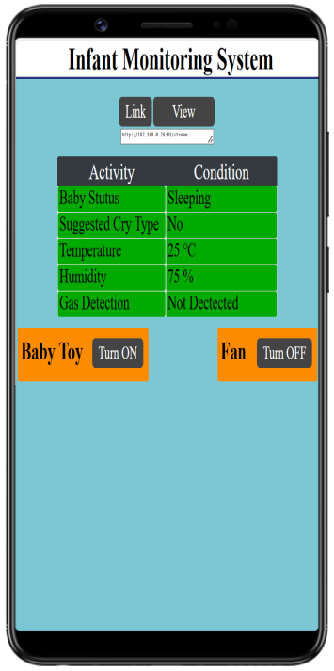

Figure-8: Mobile apps connection layout with the system.

The next step will take the user to the second layout shown in figure-9. From this layout one user will be able to monitor baby status about it’s sleepiness, suggested cry types, surrounding temperature of the baby, Humidity of the baby environment, as well as safety measures such as LPG and smoke detection. Moreover, depending on the app data baby mother can control some tools for the baby through IoT. To understand this scenario, let’s consider baby is not in sleepy mode or status. So that it may be entertained by some rotatable toy and another issue may arise due to the uncomforted temperature. There will be a load control capability so that the fan and baby toy both can be controlled from the mother’s mobile application. So, we can consider the mobile app’s activity into two major categories. Those activities can be controlled automatic and the other group those can be controlled manually.

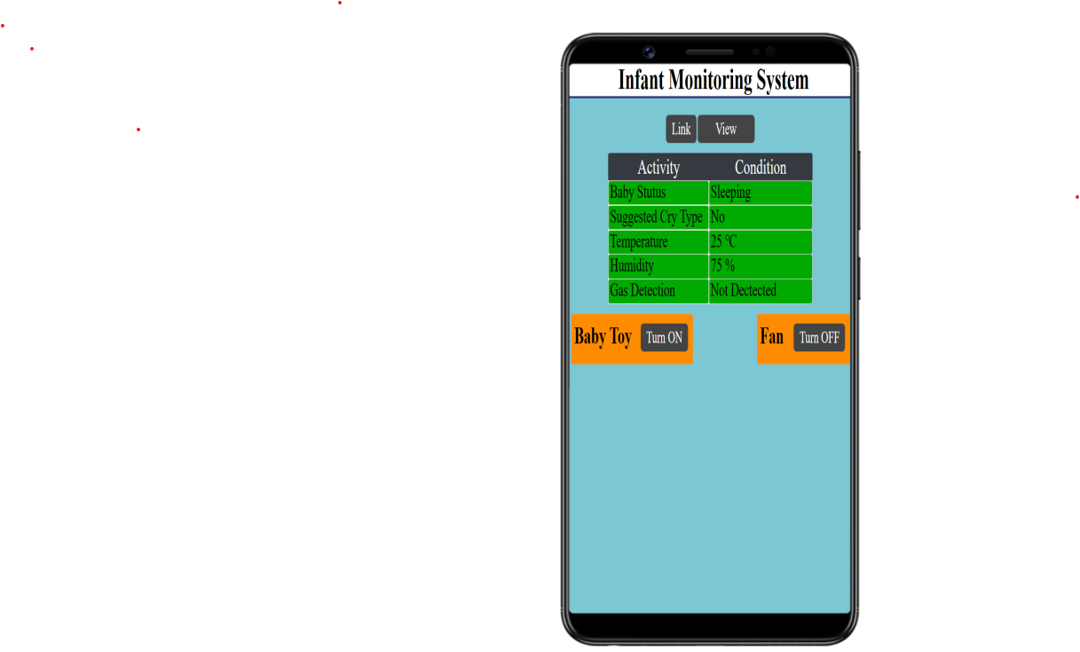

Figure-9: Baby monitoring activity layout.

Manual Control Features:

* Video Streaming: The application provides an option for the mother to initiate video streaming whenever she wants to check on her child's activities. By simply tapping the "View" button, the video streaming function is activated, allowing her to monitor her child in real-time. The video stream can be closed at any time by tapping the "Close" button.
* Fan Control: To ensure her child's comfort during comparatively high temperature, the mother can control the fan with ease. By tapping the "Turn ON" button in the fan section of the application, she can activate the fan. Similarly, if the fan needs to be turned off, she can do so by tapping the "Turn OFF" button within the same section.
* Baby Toy Control: The application also provides the mother with the ability to entertain her child using electric rotatable toy. Like fan user can tap the "Turn ON" button to turn on the baby toy, she can activate the toys for her child's amusement. When it's time to stop the play, she can click the "Turn OFF" button within the same section.

These manual operations are possible from the work table of the mother. No, necessity for moving to the baby.

Automatic Control Features:

* Cry Detection and Classification: The system is equipped with an automatic cry detection and classification feature. When the system detects the baby's cry, it not only identifies the cry but also provides suggested reasons for the crying. Additionally, it initiates live video streaming, allowing the mother to see her child and alerts her that her child requires attention and care.
* LPG or Smoke Detection: The application also incorporates LPG/ Gas detection capabilities. If harmful gases like CO, LPG, or smoke are detected in the baby's environment, the application immediately notifies the mother and provides necessary steps for her to take in response to the gas detection event. This feature ensures the safety of the child by keeping the mother informed about potential hazards.
* Mobile Call: In our Infant Monitoring System project, we have incorporated a mobile call feature designed to rapidly alert the mother when the gas sensor detects the presence of potentially harmful gases such as LPG or smoke in the vicinity of the infant. This crucial alert system is achieved through the utilization of a GSM A6 Mini Module, which allows us to establish a seamless connection between the GSM module and the ESP-32 Microcontroller.

In summary, this comprehensive set of features ensures the child's well-being while providing convenience and peace of mind to the caregiver.

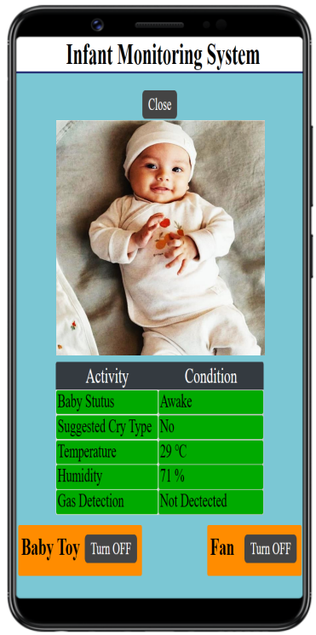

Figure-10: Video streaming activity in application layout.

## **4.2 Monitoring System Circuit Configuration:**

The proposed system can detect a crying sound and classify it into three major categories based on the signal amplitude or intensity level. The mechanism behind this classification involves a crying sound is played and the analog values are stored and noted after processing with the elimination of noise in the normal room environment. These cries are taken from a dataset and then observed by the system. Each sound was donated by individual parents and its length is 7 to 8 seconds. The analog value is collected at every 150ms and kept in an array, then the maximum and minimum analog values are noted for further processing. The maximum and minimum analog values for each category can be observed in Table-1.

From the table, we made the following decisions:

* The maximum analog value for Belly Pain/ Burp starts from 700 and the minimum analog value starts from 95 to 200 on average.
* The maximum analog value for Hungry Cry starts from 500 and the minimum analog value starts from 125 to 180 on average.
* The maximum analog value for Discomfort/ Tired Cry does not exceed 500 and the minimum analog value starts from 80 to 125 on average.

Based on these observations, the classification is done through programming and the system can classify a crying sound as either a Belly Pain/ Burp cry, Hungry Cry, or Discomfort/ Tired Cry.

## **4.3 Monitoring System Circuit Configuration:**

In the schematic diagram provided, we have a comprehensive Infant Monitoring System that utilizes various sensors and outputs to ensure the well-being and comfort of a baby.

Sensor Connections:

* DHT-11 Temperature and Humidity is connected to I/O pin-0 of the ESP32 and serves the purpose of monitoring the ambient temperature and humidity in the baby's environment. Its digital output is used for data transmission to the ESP32 Microcontroller.
* The MQ-2 sensor, responsible for detecting LPG and smoke, is connected to I/O pin-1 of the ESP32 Microcontroller. Its digital output is used to relay information about gas and smoke levels to the ESP32 Microcontroller.
* PIR Motion Sensor: Positioned to detect the baby's movements, the PIR sensor is connected to digital I/O pin-2 of the ESP32 Microcontroller. It can sense any object within ${120}^{0}$ and provides digital output signals to indicate motion.
* LM393 Sound Detection Module: This sensor is used to identify and classify the baby's cries. It offers both analog and digital output, but for this project, the analog output is connected to Analog pin-0 of the ESP32 Microcontroller. This analog signal is processed to detect and classify the baby's cries.

Output Connections:

* DC Fan Control: As mentioned before, A DC fan provides ventilation and cooling, is manually controlled via the Infant Monitoring System mobile application. It is connected to the BUILTIN LED pin of the ESP32 Microcontroller.
* Electrical Toy: An electrical toy, designed to entertain the baby, is connected to I/O pin-3 of the ESP32. To control its operation, a relay is employed. This enables the system to remotely activate or deactivate the toy as needed, providing amusement and stimulation for the baby.

GSM A6 Mini Connection: To enable connection between ESP-32 Microcontroller with GSM A6 Mini Module, we employ the Transmit (TX) pin of the ESP-32 and the Receive (RX) pin of the GSM A6 Mini Module. This communication link ensures that when the gas sensor detects any dangerous gases near the infant, the ESP-32 Microcontroller can promptly trigger a mobile call alert to the mother's designated phone number. The call will be generated from a dedicated mobile number. The associated sim will be inserted in the control module to do that and a minimum balance to be ensured in the SIM number.

Additionally, our project also integrates the ESP-32 CAM module, which plays a vital role in ensuring the safety of the infant. This module facilitates real-time video streaming of the infant's surroundings, providing parents with visual access to monitor their child remotely. This live video feed is accessible through a secure connection, allowing parents to keep a watchful eye on their infant from anywhere, enhancing overall peace of mind and infant safety [20].

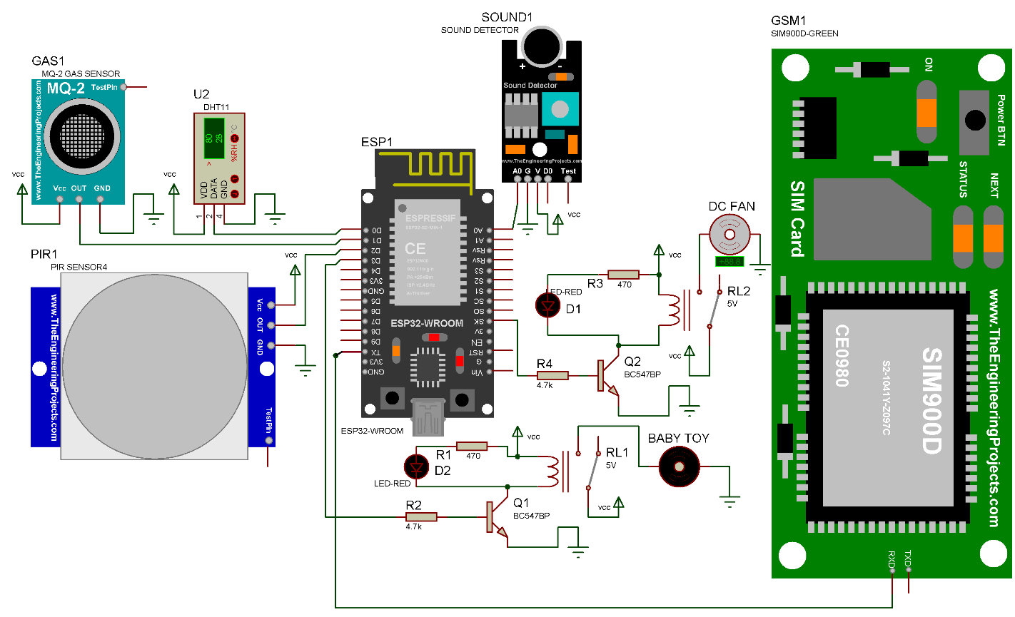

Figure-11: Video streaming activity in application layout.

# Chapter Five

# **CONCLUSION**

The proposed system is a comprehensive and innovative solution for monitoring the baby's environment and health. The system uses a variety of technologies, including hardware sensors and software applications, to collect data and provide alerts to the mother. The system also has manual and automatic control features, which gives the mother the flexibility to control the system as needed. The system is designed to be low-cost and easy to use, making it accessible to garment workers who often have limited financial resources. The system is also designed to be scalable, so it can be adapted to different settings and requirements. The system has the potential to improve the lives of garment workers and their babies in a number of ways. First, it can help to reduce the number of infant deaths and injuries caused by environmental hazards. Second, it can provide peace of mind to mothers, allowing them to focus on their work without worrying about their babies. Third, it can help mothers to better understand their babies' needs and development. The system is still in the development stage, but it has the potential to make a significant impact on the lives of garment workers and their babies. I am excited to see how the system develops in the future and how it can be used to improve the lives of people around the world.

Here are some additional details about the system: The hardware sensors include an MQ2 sensor for LPG and smoke detection, a DHT11 temperature and humidity sensor, and an ESP32-CAM module for video calling. The software applications include a web application for the mother to monitor the baby's data and a mobile application for the mother to receive alerts.

I believe that the proposed system is a valuable contribution to the field of infant monitoring. It is a low-cost, easy-to-use, and comprehensive system that has the potential to improve the lives of garment workers and their babies.

# 

**REFERENCES**

[1] Smith, J. (2023). "Impact of the ready-made garment industry on women in Bangladesh." World Bank, Washington, DC.

[2] https://rmgbd.net/2023/01/women-workforce-declining-in-rmg-sector/

[3] Ahmed, S. (2019). "Female garment workers experiences of motherhood in Bangladesh." Gender and Development, 27(2), 259-274.

[4] Khan, S. R., & Eshghi, A. (2018). "Childcare facilities and work-family conflict: A case study of the ready-made garment industry in Bangladesh." The International Journal of Human Resource Management, 1-18.

[5] Bangladesh Garment Manufacturers and Exporters Association (BGMEA). (2020). "Maternity and Childcare Facilities in Garment Factories."

[6] Uddin, M. S., & Datta, S. K. (2020). "An Exploratory Study on Problems of Female Garment Workers in Bangladesh." Journal of Business Studies, 1(1), 21-33.

[7] R. Gupta, M. Jain, and V. Chaudhary, "IoT-Based Baby Monitoring System Using Wireless Sensor Network," International Journal of Engineering and Advanced Technology (IJEAT), vol. 9, no. 6, pp. 2756-2760, 2020.

[8] Y. Wang, L. Gao, and X. Li, "A Real-Time Monitoring System for Infant Sleep Apnea Based on IoT," Sensors, vol. 21, no. 5, p. 1762, 2021.

[9] D S. Das, A. De, A. Bhattacharya, and D. Bhattacharyya, "IoT Based Smart Cradle for Infant Monitoring," in 2020 International Conference on Emerging Trends in Information Technology and Engineering (ic-ETITE), 2020, pp. 1-4.as et al. (2020)

[10] S. Sabarinathan and A. Umamakeswari, "IoT based Baby Monitoring System using Raspberry Pi," in 2019 International Conference on Electrical, Communication, and Computing (ICECCO), 2019, pp. 1-4.

[11] R. Sajeev and R. Janani, "Real-time Baby Monitoring and Health Care System Using IoT," in 2019 3rd International Conference on Trends in Electronics and Informatics (ICOEI), 2019, pp. 958-963.

[12] P. M. Shalini and D. Gunasundari, "IoT Based Smart Baby Monitoring System," in 2021 International Conference on Smart Electronics and Communication (ICOSEC), 2021, pp. 216-219.

[13] S. Bhuvaneswari and A. Kalyani, "IoT-based Baby Health Monitoring System," in 2020 International Conference on Smart Electronics and Communication (ICOSEC), 2020, pp. 424-427.

[14] A. S. Khan and M. N. Islam, "IoT Based Baby Monitoring and Controlling System," in 2021 IEEE/ACS 18th International Conference on Computer Systems and Applications (AICCSA), 2021, pp. 1-6.

[15] H. Zhang, Y. Han, Y. Liu, and L. Hu, "An Intelligent Method for Infant Respiratory Distress Syndrome Prediction Based on Machine Learning," IEEE Access, vol. 9, pp. 74049-74058, 2021.

[16] A. Alameddine, H. Tang, and N. K. Gupta, "Infant Sleep Posture and Movement Detection Using Machine Learning," IEEE Transactions on Biomedical Engineering, vol. 66, no. 5, pp. 1413-1421, 2019.

[17] D. Stojanovic, D. Prijovic, and D. Obradovic, "Machine Learning Approach for Real-Time Baby Crib Monitoring," in 2021 27th Telecommunications Forum (TELFOR), 2021, pp. 1-4.

[18] Tarun Debnath & Pallab Kanti Podder (2023). "AI Based Baby Nursing Robot." International Journal of Science and Business, 21(1), 20-31. doi: https://doi.org/ 10.5281/zenodo.7574912

[19] "ESP32 - Espressif Systems." Espressif Systems.

<https://www.espressif.com/en/products/socs/esp32>. Accessed August 4, 2023.

[20] <https://youtu.be/jpT8fsdN6qA?si=y9HJI0uoMvMclyjX>. Accessed August 12 2023.

[21] Donateacry-corpus. (2019, 3 6). Retrieved from Github: https://github.com/gveres/donateacry-corpus

|  |
| --- |
|  |

# 

# **ABBREVIATIONS**